Inna London M.D., LLC
16220 Frederick Rd., Suite 420
Gaithersburg, MD 20877
Phone: (301) 330-3335
Fax: (301) 330-3359

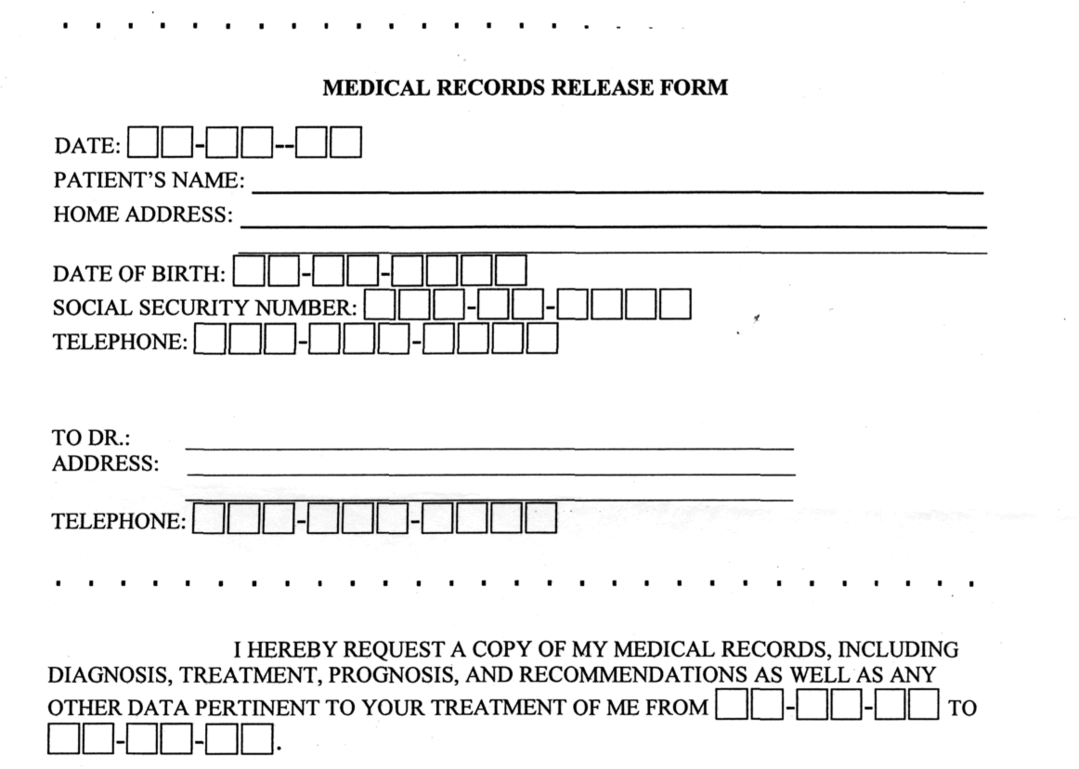

I UNDERSTAND THAT THESE MEDICAL RECORDS MAY CONTAIN
REFERENCES TO MENTAL HEALTH, SUBSTANCE ABUSE, AND/OR HIV/AIDS RELATED INFORMATION.
PLEASE RELEASE THESE RECORDS TO INNA LONDON M.D., L.L.C. AT THE ABOVE ADDRESS.

